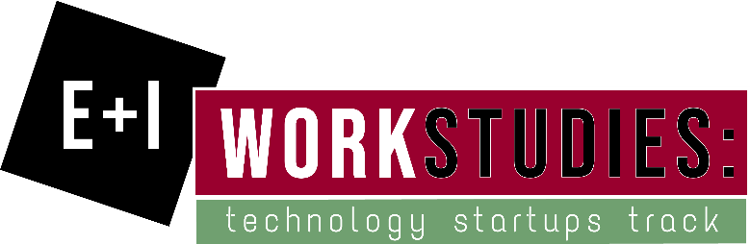

Want to make a difference in the way you and your fellow students find jobs and internships? Want to work with a team of entrepreneurs that are building the future of work? Want to gain valuable experience in the fields of data, sales, and internal relations with a growing tech startup? Consider an E+I work study with Candidit next semester!

Working up to 10 hours per week from February 4th through April 26th, you’ll have the opportunity to help map classes at Grove City College to an advanced system which includes 30,000 competencies. Improve your sales skills by communicating with companies that want to hire Grove City Students and assisting in on-boarding these companies into the Candidit system! Learn to develop taxonomies and how to structure massive databases for the collection of large amounts of data! Develop an understanding of cutting-edge technologies like blockchain and artificial intelligence! And perhaps most importantly, have fun working and learning alongside other highly motivated students…did we mention you’ll get paid for your work and that you’ll be doing the work on campus?

Learn more about what the project is all about here: https://www.linkedin.com/pulse/path-competency-based-employment-logan-hammerschmitt/?published=t

In order to be considered for the job, you should know these things or be willing to learn them…

Knowledge - Have experience with the following:
- Sales
- Interpersonal skills

Tools - Have access to and mastery of:
- Cell Phones
- Computers

Technology - Have experience with of:
- Google Suite
- Email
- CRM systems

Activities - be comfortable with the following activities:
- Sales calls
- Interviews
- Competency matching

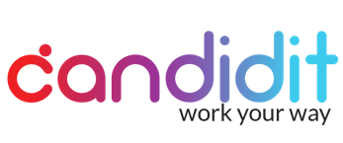

About Candidit: Candidit, the user facing platform developed by Redcell LLC, is changing the way the world works. Using a Competency-Based Hiring approach makes it easier for companies to find the best fits for their jobs and for job seekers to find jobs that they are most likely to excel in. Using our platform, users can find careers that might interest them, investigate real pathways to those careers, and ultimately discover where they are most likely to succeed. Users can also register to unlock powerful features that will keep track of the competencies they have earned while completing classes and in past jobs and allow them to develop a profile of career interests that becomes smarter as they add to it. (https://candidit.com)

About Redcell LLC: Redcell LLC is developing a world-class talent exchange based on a combination of blockchain and AI to move companies and job seekers beyond the legacy and stagnant sourcing mix of job boards and contingency hiring firms to a powerful, transparent employment registry focused on aligning skills and behaviors to optimally fit real-time needs for both employees and employers.

For more information and to apply, please visit gccentrepreneurship.com > Programs > Work Studies.
Applications due by Study Day, December 13, 2018.

