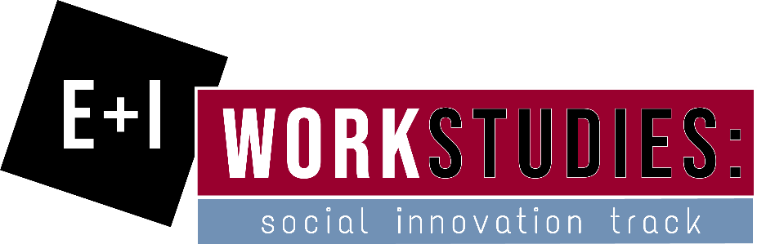
Would you like to help those in Grove City and the surrounding region that need it the most? Thanks to a paid internship through the E + I work study program, you will have the opportunity to assist the Community Foundation of Western PA & Eastern OH in building an in-depth needs assessment of our region that will help its donors' grant money to have more of an impact in the community.
The time commitment for the internship will be up to 10 hours per week between February 4th and April 26th, when you will be working directly with the Community Foundation's Executive Director and Board Members to enhance the organization's services to its donors.
You will be educated and then empowered to work directly with other non-profit organizations to identify gaps in service that grant dollars from the Community Foundation will be able to fill, thereby building a better future for local children, adults, and seniors (and animals!) throughout our region.
This is your chance to help make a huge difference in improving the lives of other people in our community!
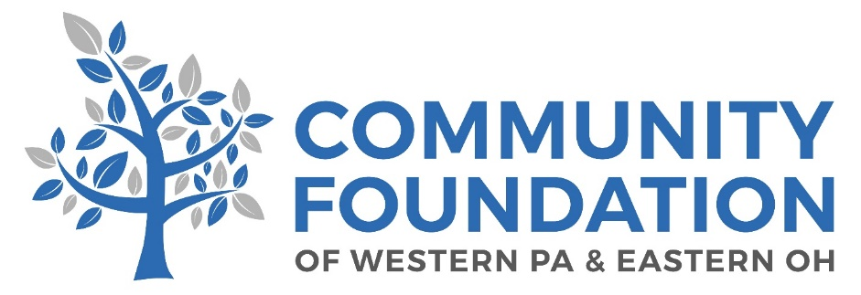
About the Community Foundation of Western PA & Eastern OH: Donors within our local community foundation grant out in excess of $5 million dollars on an annual basis. This grant money goes to help support organizations that are working in fields such as hunger, spousal abuse, economic development, education, and advocacy for children. Since being founded in 1981, the Community Foundation has helped its donors grant out over $75 million to support local charitable efforts.

For more information and to apply, please visit gccentrepreneurship.com > Programs > Work Studies.
Applications due by Study Day, December 13, 2018.

